Lab 6: PD Control

EEE4514

Marcel 1, 2017

**Gabriel Stroe**

# Filtering

## Overview

The purpose of this lab is to create a PD controller so that we can improve the frequency response time and overshoot while sacrificing some of the steady state performance.

## Theory and Methods

Below is the model for the PV position control that we will be using:

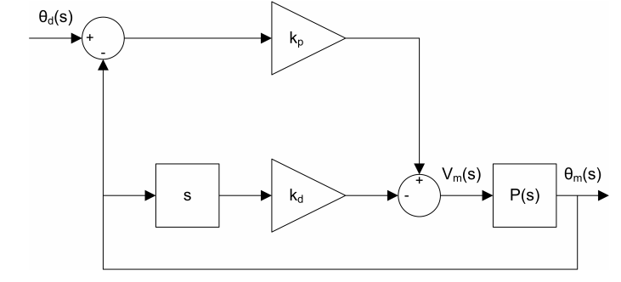Here we will be scaling the Kp constant which is the proportional scaler, and Kd which is the derivative constant. It can be inferred as the derivative constant as it is being multiplied by s. The basis for this lab is modifying these two constants

## Results

Listed in the figures bellow are all the outputs from our testes. Based on the results we were seeing we were able to understand how each value effects the response curve.

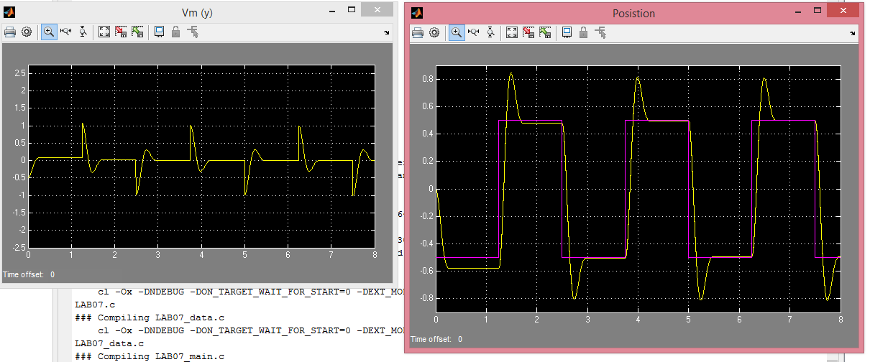

Figure 1: Kp = 1, Kd = 0

Here the system has no derivative scaling and unit gain for the proportional scalar.

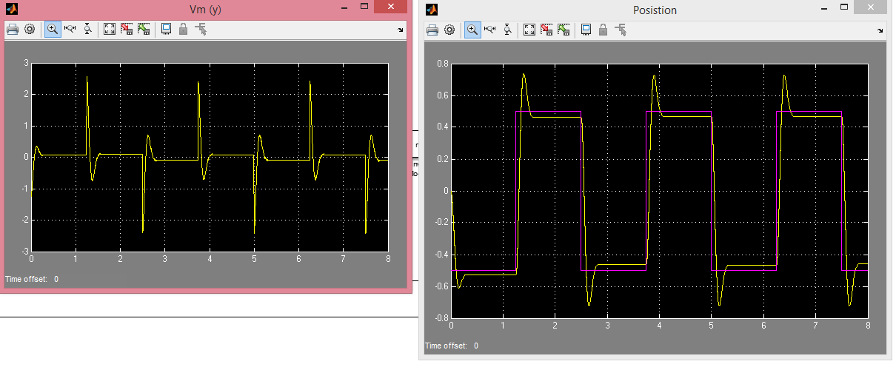

Figure 2: Kp = 2.5, Kd = 0

Here increasing Kp decreases the rise time at the cost of a much worse steadystate value.

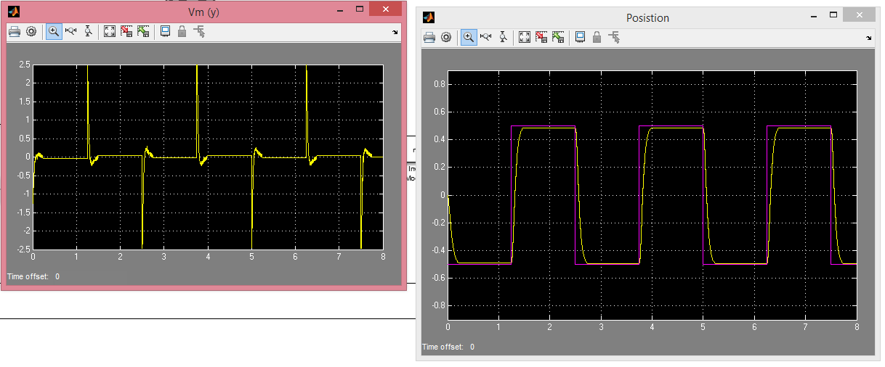

Figure 3: Kp = 2.5, Kd = 0.15

Here we add a small Kd. It improves our steady state value but lowers the rise time and causes the system to become underdamped.

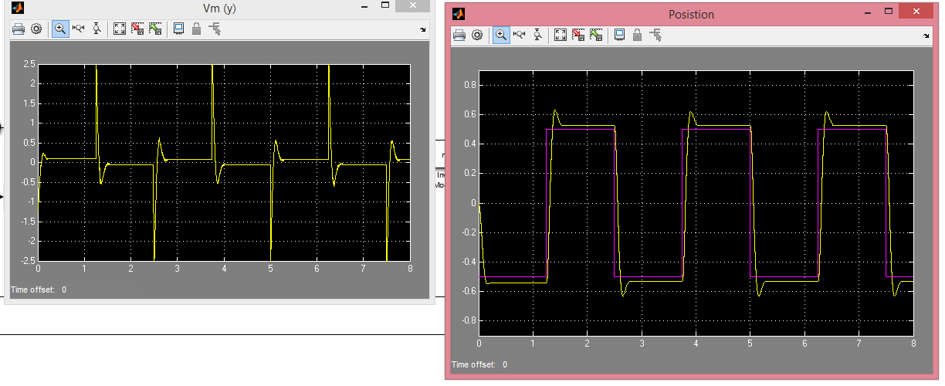

Figure 4: Kp = 2.5, Kd = 0.0075

Now we have lowered Kd which decreases our rise time and causes some overshooting again. This is most likely the best result we have seen so far.

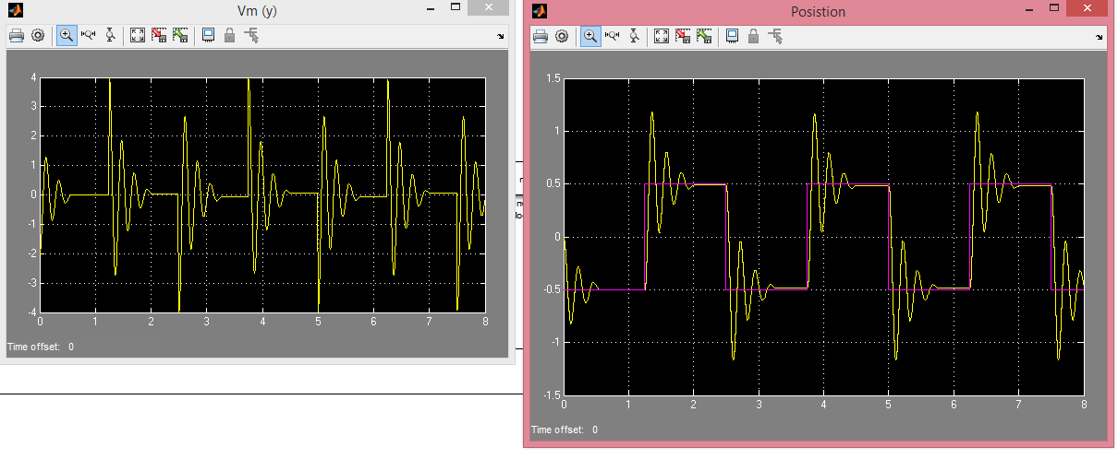

Figure 5: Kp = 4, Kd = 0

Here the system has no derivative scaling and Kp is set very high causing a very fast rise time at the cost of massive overshoot and osilations.

For the final example we used the formulas provided in the lab to solve for the Kp and Kd when applied to the servo motor and found that they should be Kp = 5.38 and Kd = 0.232. when applying that to our system we got the following results:

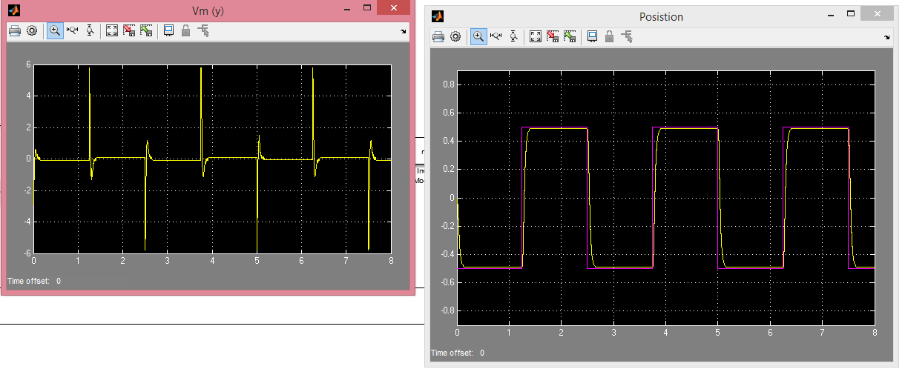

This was a little overdamped and not quite a perfect match. Increasing Kp would most likely help solve this but unfortunately we did not have enough time in the lab to test this. Once again we used the manual’s specifications for the servo motor values which I believe is slightly off of the actual values do to some wear and tear on the system over the years.

## Questions

1. The increasing gain causes a much faster rise time, a greater overshoot and oscillation before settling into the steady state response.
2. At 0.075 the rise time is slower, and overshoots the target response with a significant steady state error. At 0.15 the rise time is slow and has a significant steady state error.
3. Kp = 5.28, Kd = 0.232
4. No they do not. Increasing both values slightly should help achieve this, primarily the Kp. Unfortunately, we were not able to test this.